Week 2 Exercise: Python Data Types: Instructions

Due Date: End of week 2

After working through the Module 1 Python Bootcamp tutorials, this should not be a difficult exercise. The goal here is to move away from formal tutorials and be able to read and analyze ‘correct’ code applied to one dataset, and then adopt (cut and paste) that code in a different code cell or Jupyter Notebook, modify the code (as needed) and apply the modified code to a different dataset.

You will find an abbreviated version of these Exercise instructions in the datatypes.py file within the #comments.

**When you have completed the modification of the #Datatypes code (at the very end of this document), also contained in the datatypes.py file, you should submit datatypes.py to the LEO Assignments area.**

# Running Python

You should cut and paste the code into either a Jupyter notebook to run. You run the Python notebook code by clicking on the triangles in the circle to the left. **You can copy an entire python code file into a single code cell as in Figure 1; or you can copy consecutive code chunks into separate code cells, as in Figure 2. This is an important point. In this course you will be presented with longer and longer code segments as the course progresses. Knowing how and where to cut code into smaller sections will help with your understanding of the code and with troubleshooting should you encounter an error.**

In Jupyter you can paste chunks of code, in different code boxes, which makes it easier to understand and digest the code. 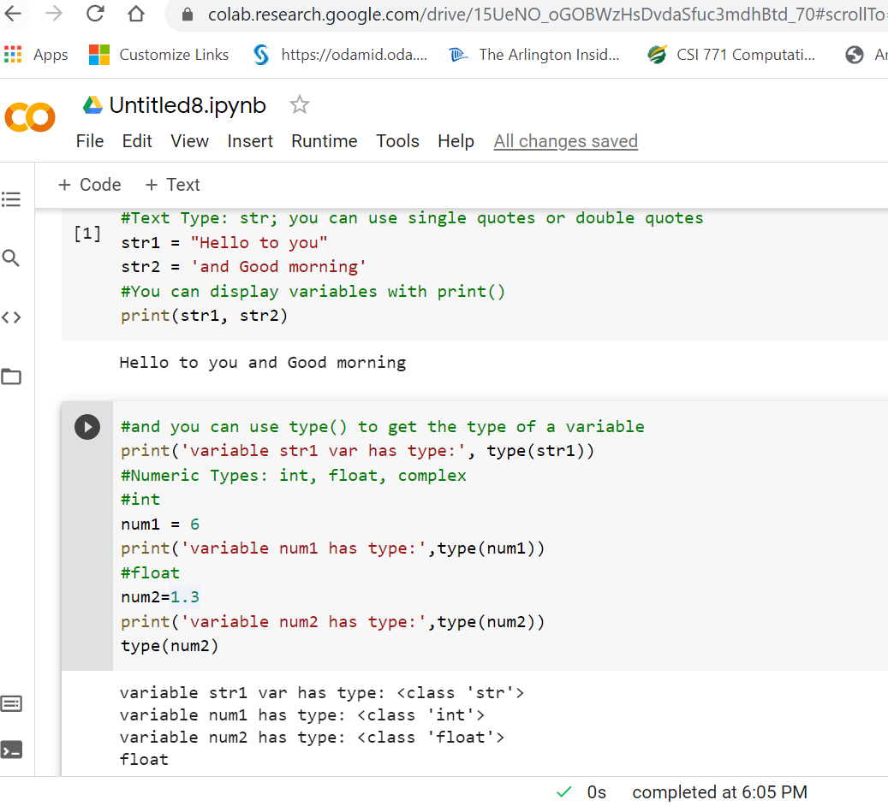

Figure Pasting .py code into one code cell in the Python Notebook in Google Colab

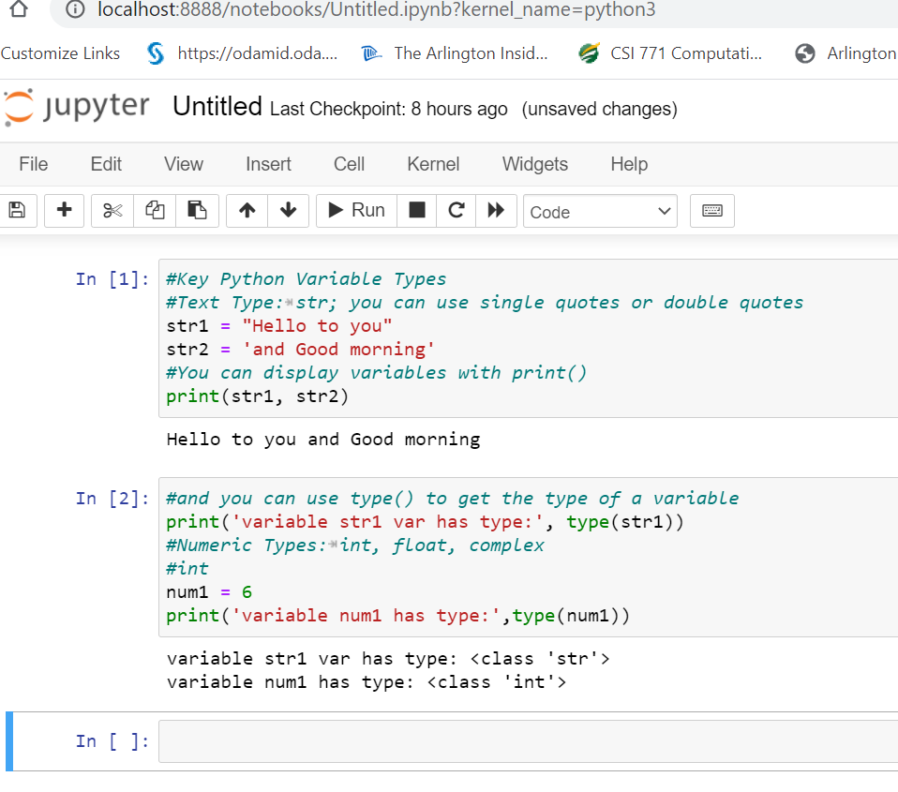

Figure Pasting consecutive chunks of code into separate code cells in the Python Notebook in Jupyter if you install locally

To add new code cells, click on +Code, as in Figure 3 in Google Colab:

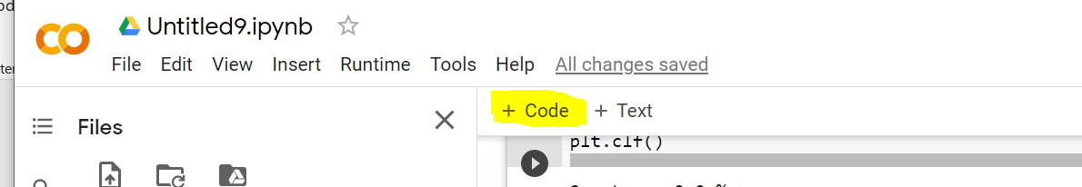

Figure Click on Code + to add a new Code Cell to the Python Notebook

And you can click on “+Text” if you want to add text as an explanation to your code in your notebook.

You can rename your python notebook to whatever you please. For example, see Figure 4.

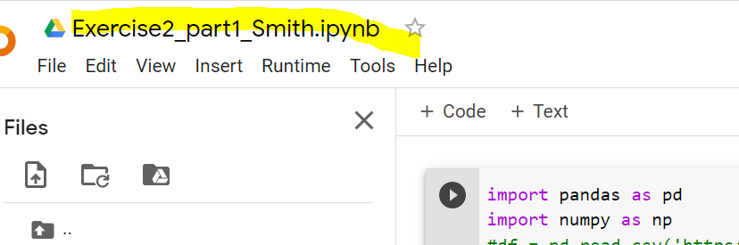

Figure Changing the Python Notebook Name

## Uploading Datasets on Google Colab

If you use Google Colab, you need to upload the data sets. One way to do this is to:

Just remember that uploaded data files will get deleted when this runtime is recycled. If the notebook is **idle for some time**, it might get recycled: "Virtual machines are recycled when idle for a while" (see [colaboratory faq](https://research.google.com/colaboratory/faq.html)) There is also an imposed hard limit for a virtual machine to run (up to about 12 hours !?).

Your python notebook file (.ipynb) will be saved forever, but your data files will need to be re-uploaded into Google Colab if the virtual machine is recycled.

## Exercise 1: Part A: datatypes.py

Exercise on Python Data Types:

1. Read, study and execute datatypes.py; you can copy the entire code from the file

or from the word document or parts of it into code blocks in a Jupyter workbook and execute it there.

1. Modify the following code, #Datatypes such that if the elements are of type(class) float, then add 5 to the previous value. This code loops through all items of list3 and if they are of type str, then it appends 'of course' (you should keep this code intact, the output should add 5 to float types and add ‘of course’ to str types). Notice that when we indent statements, we should hit tab [or hit space 4 times.]
2. Submit ONLY your code as datatypes.py

#Datatypes

list3 = list(('hello',1,'you',6.3,'yes',7,2.3))

#Comment here

for i in range(len(list3)):

if str(type(list3[i])) == "<class 'str'>":

list3[i]=list3[i] + " of course"

#Comment here

print('list3=',list3)